**Software Development Project 1**

**COMP231 SEC001**

**TEAM 5**

**User Role Modeling**

Group member:

Hui, Siu Wai

Kayastha, Ronan

Kela, Sandhya Dineshbhai

Prabhaker, Naman

Singh, Prabhjot

**Heal care system overview of different user:**

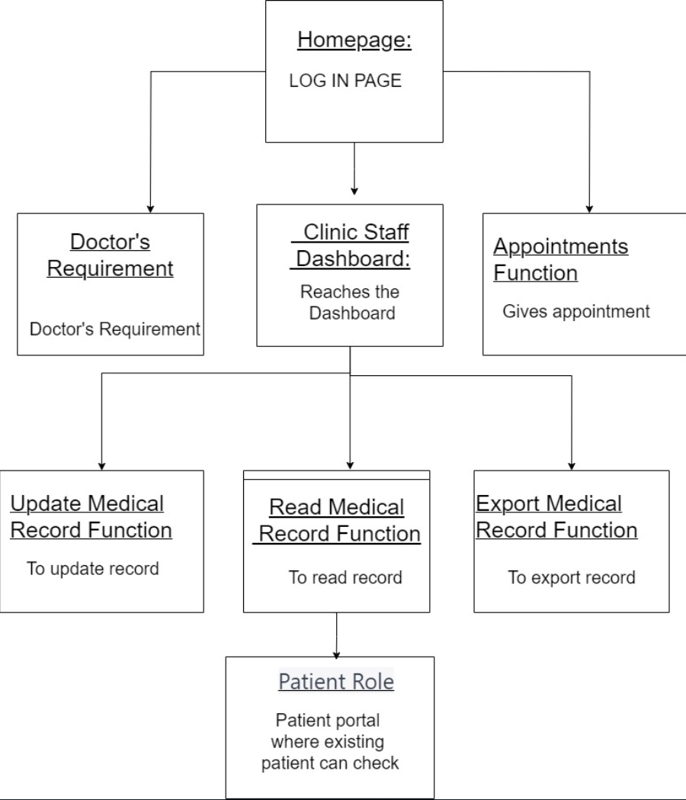

### 

|  |  |
| --- | --- |
| User Story of Clinic staff | Function |
| As a Clinic Staff (All staff), I want to use the system after login since all the patient data should kept private and not allowed to be displayed to those who do not have access account and password. | Login function: Require account and password |
| As a Clinic Staff (clinic receptionist), I want to schedule patient appointments in the system to ensure all appointments are well managed and reduce patient waiting time. | Appointments scheduling function |
| As a Clinic Staff (nurse), I want to access the patient's medical history, medications, and lab results to provide the appropriate service. | Read patient medical history function. |
| As a Clinic Staff (billing specialist), I want to generate and submit accurate insurance claims directly from the system, streamlining the billing process and reducing errors. | Read patient medical insurance function. |
| As a Clinic Staff, I want to create reports and analyze patient data to see the trends of what medical service will be most needed. | Export patient medical history function. |
| As a Clinic Staff (medical assistant), I want to easily update patient information, such as contact details, allergies, and medical history, to keep records accurate and up to date. | Read and update patient information. |
| As a Clinic Staff, I want to access the patient’s prescription history and medication list to ensure the medications I provide are accurate. | Read patient medical history function. |

|  |  |
| --- | --- |
| User Story of Doctor | Function |
| As a Doctor, I want to use the system after login since all the patient data should kept private and not allowed to be displayed to those who do not have access account and password. | Login function: Require account and password |
| As a professional doctor, I want to access and edit patient health care records electronically so that I can provide efficient and accurate medical care. | CRUD for patient medical history. |
| As a new graduate doctor, I want to easily retrieve patient information from electronic devices like iPads, eliminating the need for manual record-keeping. | Cross platform and easy to access. |
| As a doctor, I want the system to securely store patient data, including disease diagnosis, prescribed medications, and treatment periods, to streamline record-keeping and improve data security. | Data secure for patient privacy. |

|  |  |
| --- | --- |
| User Story of Patient | Function |
| As an existing patient, I want to log in to the system to check my profile and medical history, allowing me to stay informed about my health records. | Login function: Require account and password |
| As a new patient, I want to easily create a new healthcare record in the system, providing my personal information, medical history, and allergies. | Create patient account. |
| As a patient, I want the option to submit my past healthcare history to the system independently or with the assistance of staff. | Update patients heal care history. |
| As a patient, I want to export my healthcare history from the system, enabling me to share this information with referral clinics when needed. | Export patient information. |

|  |  |
| --- | --- |
| Function description | Test of the function |
| Login function:  User can enter their account and password to login to the system.  The login system is a login page containing two textboxes for the user to enter their account and password. There will also be a login button.  Estimate (UI): 3 hrs.  Estimate (Function): 6 hrs. | Test with normal staff account and admin staff account.  Expected outcome: both accounts should log in within 5 seconds, only the admin account has the permission to create a new staff account. |
| Appointment Scheduling function:  Staff can add the patient to the upcoming appointment even if the patient is a new patient.  The function is on the appointment page with a list of scheduled appointments and a button to create new appointments.  Estimate (UI): 6 hrs.  Estimate (Function): 9 hrs. | Test the function on the appointment page and click the add appointment button, add patient information, and help them create an account if they were new patients.  Expected outcome: after adding the new appointment, it will appear on the page within 5 seconds. |
| Read medical record function:  Staff can read patient medical records by entering the patient number on the record page.  The function is on the patient record page, there will be a search bar that allows the staff to enter patient information.  Estimate (UI): 6 hrs.  Estimate (Function): 9 hrs. | Test the function on the patient record page and enter the testing patient number between 0000 to 9999.  Expected outcome: after entering the patient number, only one result equal to the input value record is found. |
| Update medical record function:  Staff can update the patient record on the medical records which can be redirected from the appointment page.  The function allows staff to insert or update patient records.  Estimate (UI): 6 hrs.  Estimate (Function): 9 hrs. | Test the function on the patient record page and appointment page to see if the staff can access the patient profile and click the update button.  Expected outcome: After clicking the update button, the staff can now edit the old record or insert new record to the patient profile. |
| Export medical record function:  Staff can export patient records on the record export page.  Patient can export their own record.  There will also be a search bar to select the corresponding patient record. For example, selecting the patient within Winter 2023 for further analysis.  Estimate (UI): 6 hrs.  Estimate (Function): 12 hrs. | Test the function on the export patient records page. Staff can enter different keywords such as the date and time.  Expected outcome: after entering the keyword, the result will display as a list form showing 15 results per page. There will be an export button on the top of the page. After clicking the export button, the staff can save the file.  Test the function on patient account and click the export button.  Expected outcome: patient should automatically download the record after clicking the export button. |